ELBOW

User Manual

- Parts of the Elbow
- Methods of the Usage and Operation
- Tips and Warnings

Elbow
(DY05933L(S), DY05933L, DY059331L, DY05937L, DY05937L-RD, DY05937L-BK)
  - Parts of the Elbow
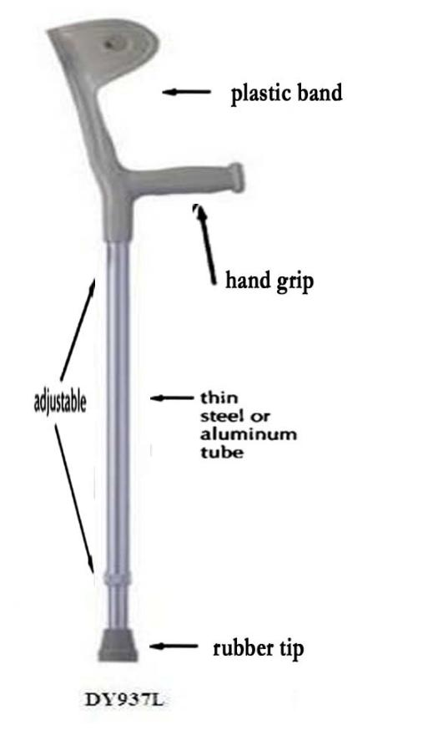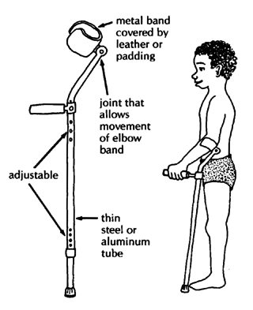2.Methods of Usage and Operation
1). To Sit:
    - Make sure you are close to the chair so you can feel it on the backs of your legs
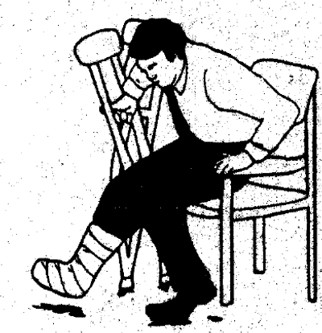
    - Get your balance on your good leg so your injured leg is off the floor
    - Take the crutches off your arms
    - Hold both the crutches in one hand by the handgrips
    - Feel for the arm of the chair with the other hand
    - Lower yourself into the chair

2). To Stand:
      - Hold crutches in one hand by the handgrips
      - Push up on the arm of the chair with the other hand to stand onto your good leg
      - Stand up and slip your arms through the arm clasps
Never sit down or stand up with the crutches on your arms.

3). To Walk:
- Keep your elbows into your sides
- Place crutches forwards shoulder width apart
- Lean on the crutches so they are used to take the weight off the injured leg
- Step through with the good leg
- When you have your balance, repeat stages 1- 4
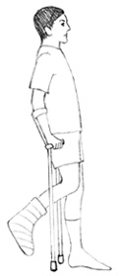
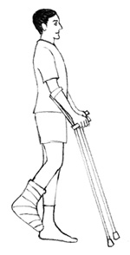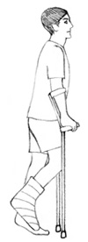

4). Stairs:
Ascending:
- Keep the injured leg off the floor and behind you
- Step up one step with your good leg
- Move your crutches onto the same step and repeat as required
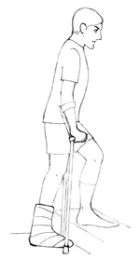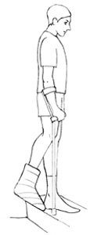

Descending:
1. Keep the injured leg off the floor and in front of you
2. Move your crutches down one step
3. Move your good leg onto the same step
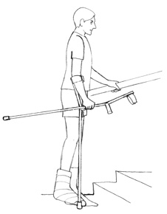
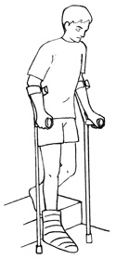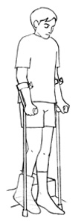
Stairs with a handrail: It is advisable to use a handrail if available. Hold onto the handrail with one hand and hold both crutches in the other hand so that one is still used to help take your weight.

3.Tips and Warnings
- Remove any obstacles such as loose rugs or cables. Wear a flat shoe on the good leg and avoid wet floors. Watch out for uneven surfaces, and inadequate lighting.
- Check regularly that the rubber ends are not worn or clogged with dirt or stones, or that the tubes have any areas of damage. If you have a problem with your crutches return them to the department that issued them to you.

